WEEK 2 STATUS REPORT
Project Title:
High Availability Router Project using HSRP and GNS3.
Course:
Computer Networks Lab
Submitted To:
Sir Muhammad Fahad Irshad
Submitted By: (Group 6)
- Sumaiya Bibi F2024266340
- Rameen Junaid F2024266341
- Tayyba Shahzad F2024266348
- Eshmal Zahid F2024266755
Introduction:
This project aims to design and implement a High Availability Router network using GNS3. The network consists of routers, a switch, end devices, and a Kali Linux machine. The objective of Week 2 was to implement the designed topology, configure devices, establish network connectivity, and verify secure remote access through SSH.
Objectives:
- Implement the network topology in GNS3
- Configure routers, switch, and end devices
- Assign IP addresses to all devices
- Verify network connectivity
- Test communication between devices using ping
- Verify VLAN functionality
- Establish SSH access from Kali Linux

COMPELTED TASKS
Network Topology Implementation:
The network topology designed in Week 1 was successfully implemented in GNS3. All required devices including routers, switch, PCs, and Kali Linux virtual machine were added and connected according to the project design.
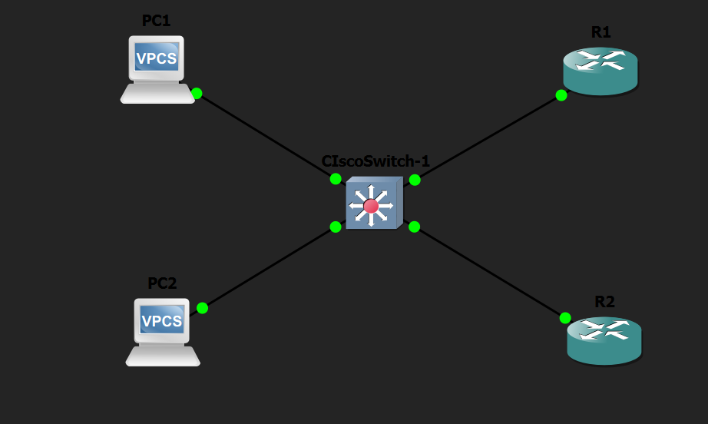

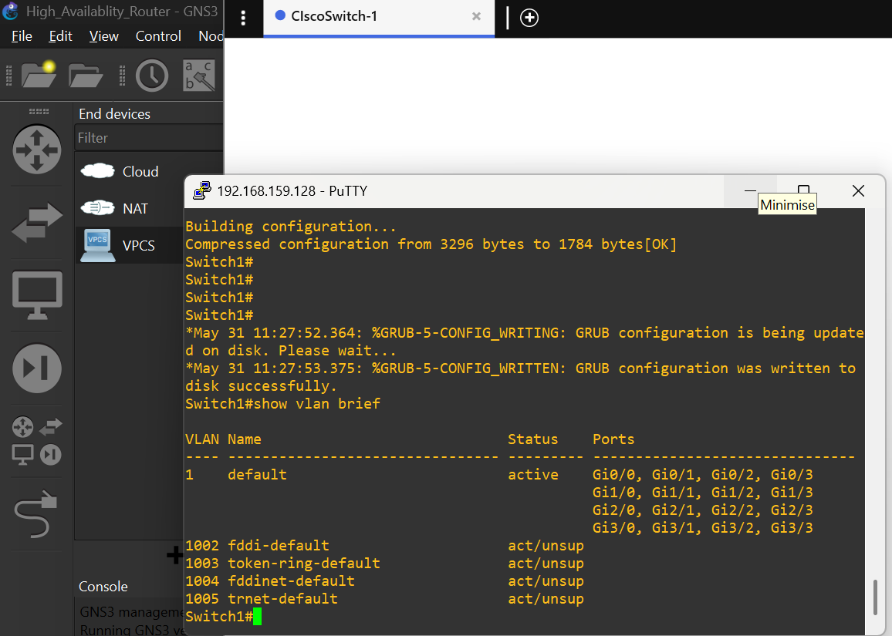
Device Configuration:
Basic configuration was completed on routers and switch. IP addresses were assigned and interfaces were activated successfully.
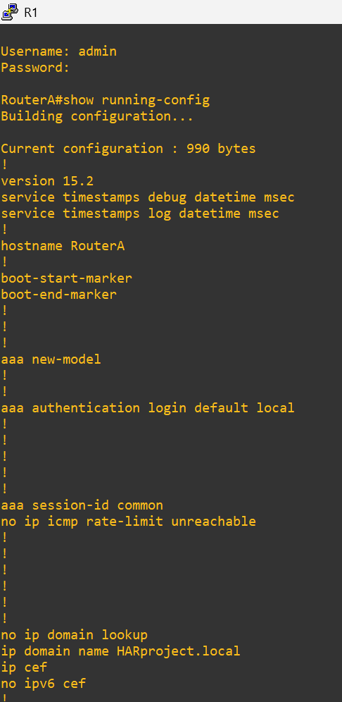

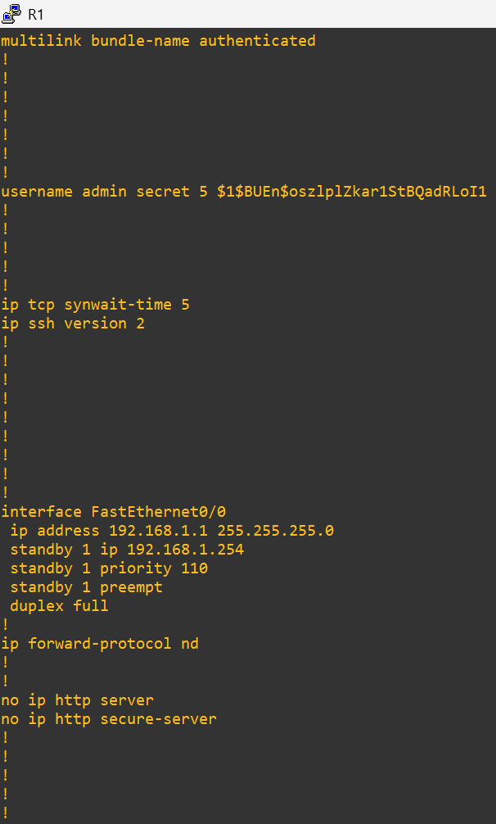
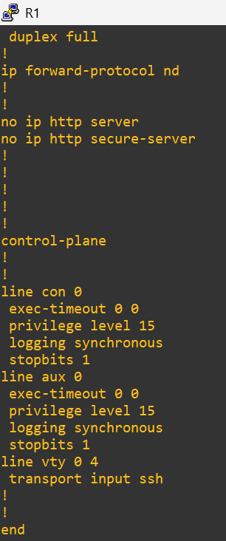

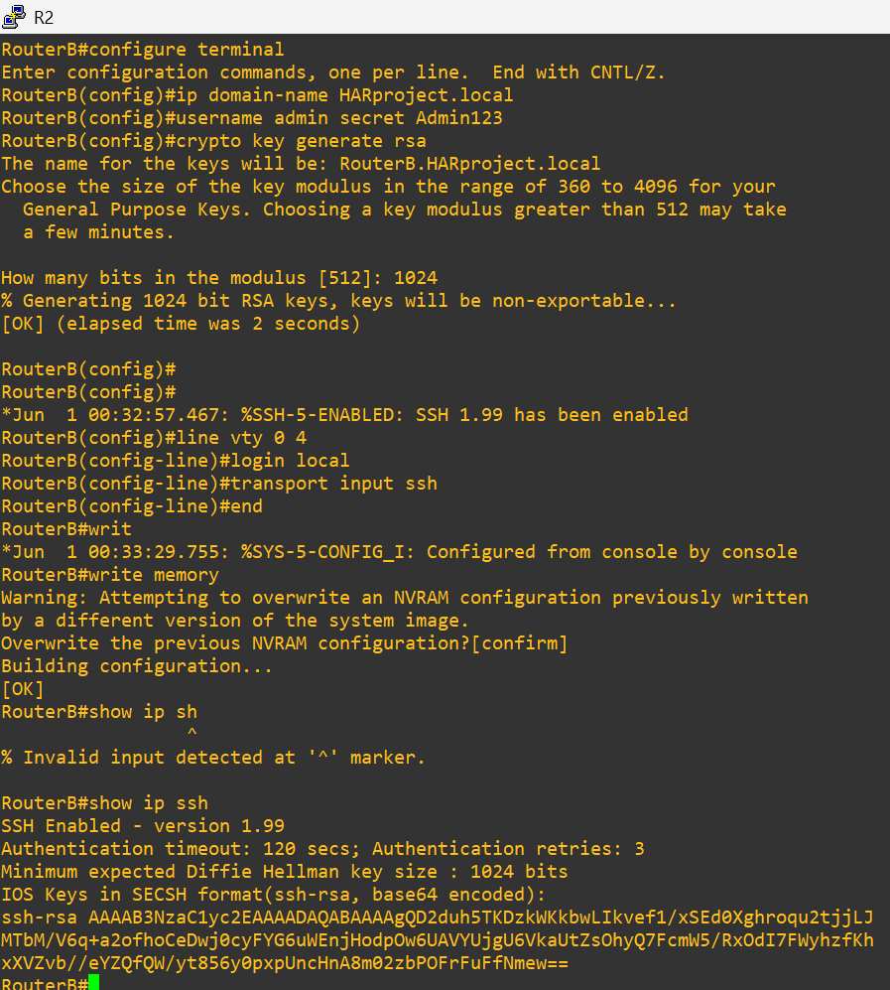
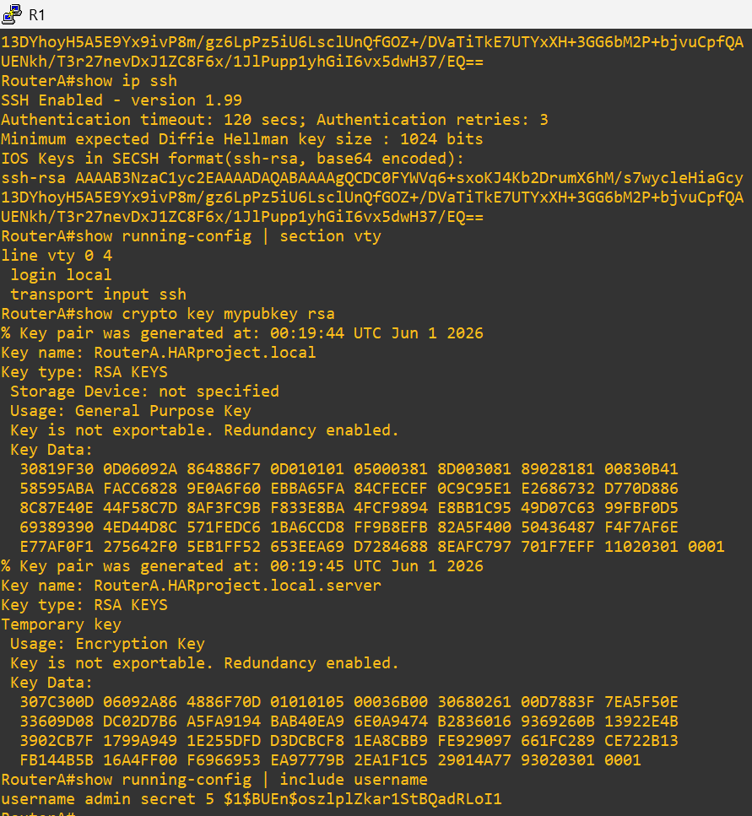
SSH Enabled in Router A and Router B:

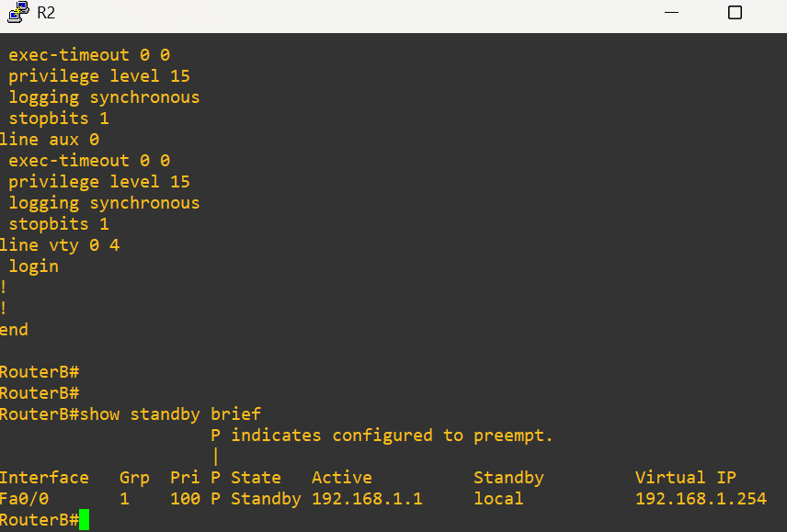
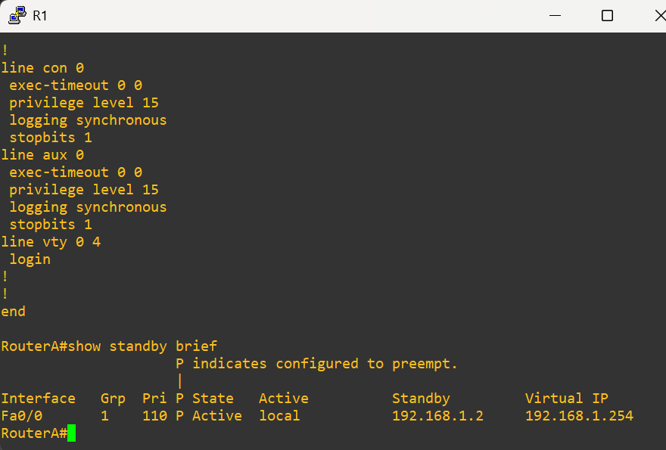
HSRP Verification on Both Routers:

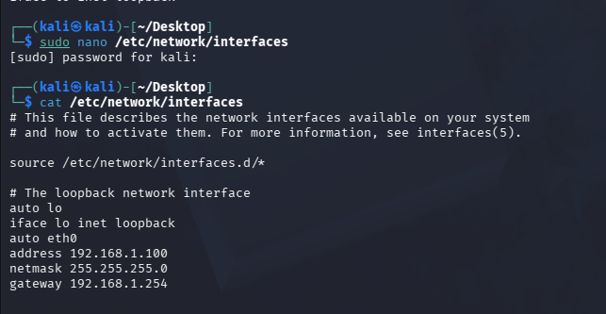
IP Addressing Configuration:
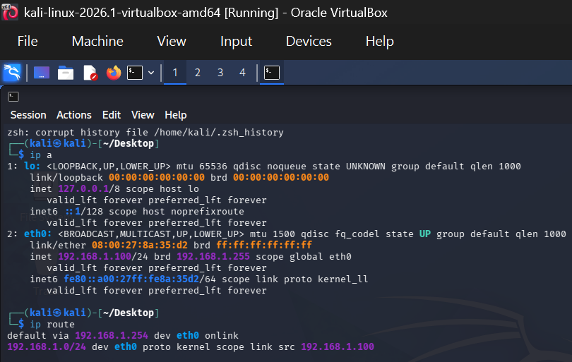
IP addresses were configured on all devices according to the addressing plan. Routing information was verified to ensure proper communication within the network.
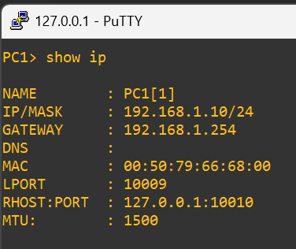

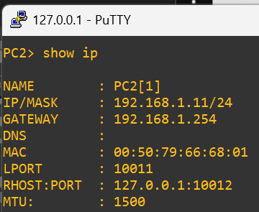

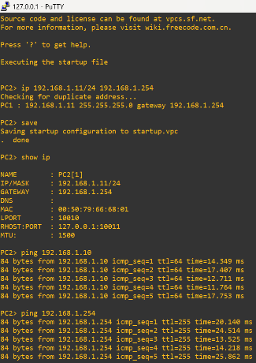
Connectivity Testing:
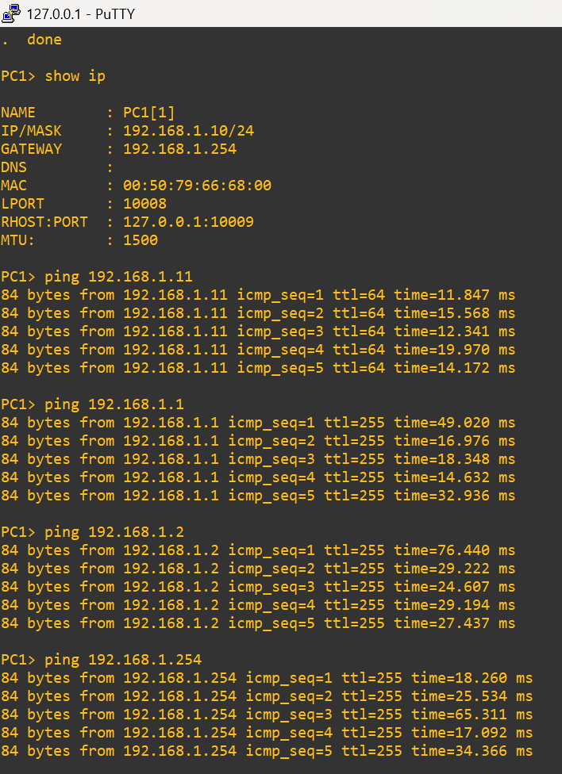
Connectivity testing was performed between network devices. Ping tests confirmed successful communication across the network.

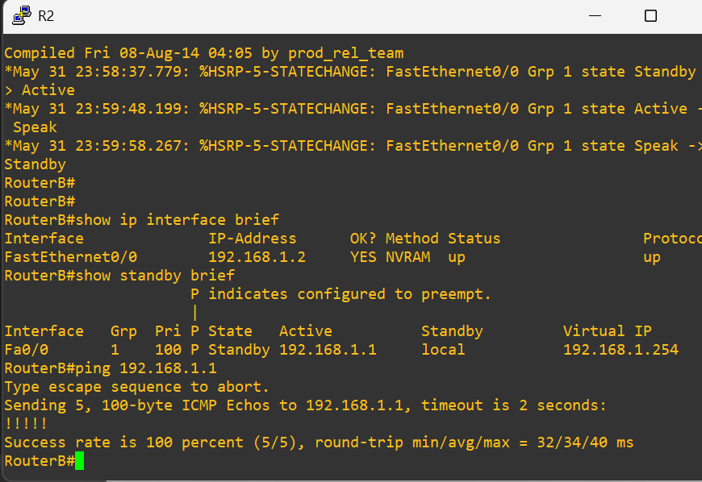
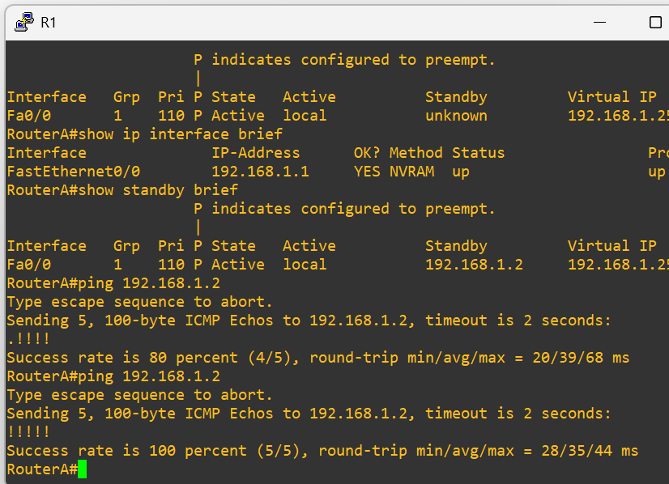

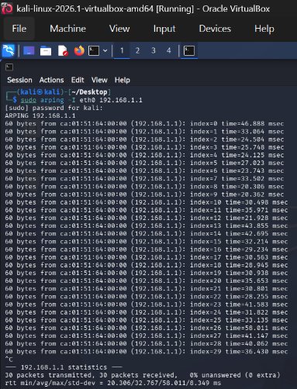
Kali Ping with Both Routers and Pc1
ping to [pc2 and both routers and same
for pc2 and for both routers A and b.

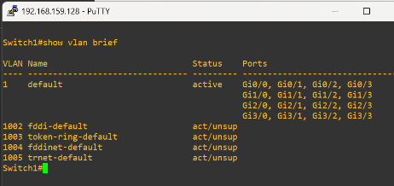
VLAN Verification:
Switch VLAN configuration was verified successfully
using switch verification commands. VLAN operation
was confirmed through connectivity testing.
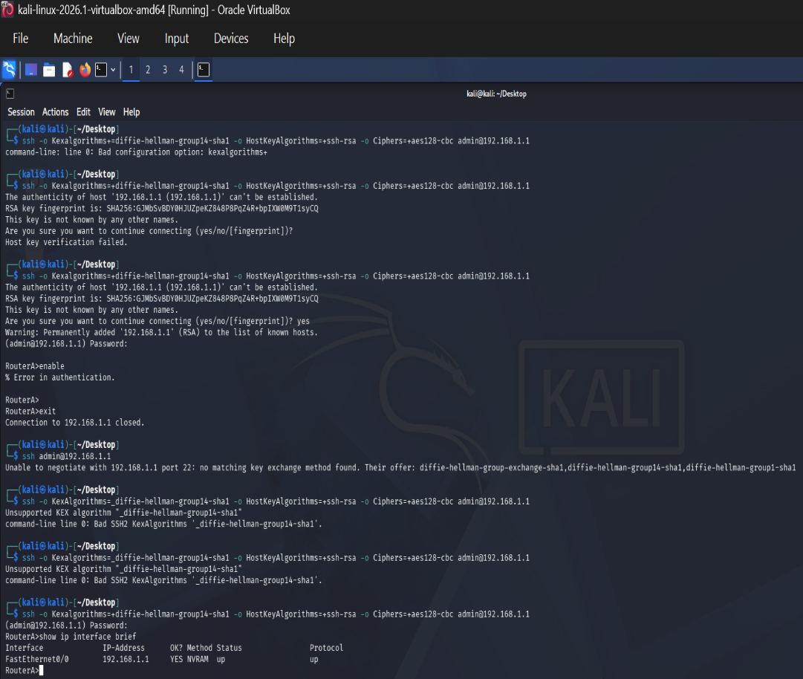
SSH Login Verification:
Secure remote access was successfully established
from Kali Linux to the router using SSH.
Connectivity and authentication were verified
successfully.

GitHub Repository Update:
Project files, configurations, and supporting documentation were updated and maintained in the GitHub repository.
Repository Link:
https://github.com/Rameen1630/HSRP-High-Availability-Router
Challenges Encountered:
- Initial connectivity issues between Kali Linux and router.
- ARP resolution issues during testing.
- SSH compatibility issues due to legacy encryption algorithms.
Solutions Applied:
- Verified switch port connectivity.
- Confirmed IP addressing and routing configuration.
- Updated SSH connection parameters to support older router algorithms.
- Re-tested connectivity after configuration adjustments.
Conclusion:
Week 2 objectives were successfully achieved. The network topology was implemented in GNS3, devices were configured, connectivity was verified through ping testing, VLAN functionality was confirmed, and SSH access from Kali Linux to the router was successfully established. The project is now ready for Week 3 security implementation activities.

